NAME :BILAL ABID ABBASI
ID:45961:
LAB TASK 07:
ASSIGNMENT 02.

Question 1:

University Management – Inheritance of Person to Student Scenario: A university needs a basic student record management system. Each person in the university has general attributes like name and age, while a student additionally has attributes such as student ID and enrolled course. To avoid redundancy and promote code reusability, inheritance should be used where common properties are defined once and reused by derived classes. Create a base class Person with attributes like name and age and a method displayInfo(). Then, define a derived class Student that inherits from Person and includes additional attributes like studentID and courseName, along with its own method displayStudentInfo(). Use these classes to display student records. The data can be hardcoded or taken as input. This structure simulates how educational institutions model their student and personnel records in real applications. This lab task simulates a real-time university scenario of managing student data using object-oriented concepts like inheritance. In the main() method, create an object of the Student class, assign values to its members, and invoke both base and derived class methods to demonstrate how inheritance makes your code cleaner and extensible.

SOLUTION:

#include <iostream>
using namespace std;
class Person { //class
protected:
string name;
int age;

public:

void setPersonInfo(string n, int a) { //function making
name = n;
age = a;
}

void displayInfo() { // Function to display person data
cout << "Name: " << name << endl;
cout << "Age: " << age << endl;
}
};

class Student : public Person { // Derived class
private:
string studentID;
string courseName;

public:

void setStudentInfo(string id, string course) { //function
student = id;
courseName = course;
}

void displayStudentInfo() { //display student data
cout << "Student ID: " << studentID << endl;
cout << "Course Name: " << courseName << endl;
}
};

int main() {

Student s1;
s1.setPersonInfo("bilal abid abbasi", 20);
s1.setStudentInfo("45961", "Computer Science (cs)");

cout<<"******************************************"<<endl;

cout << "Student Record:" << endl;
cout << "----------------" << endl;

s1.displayInfo();
s1.displayStudentInfo();

cout<<"******************************************"<<endl;

return 0;
}

Output:

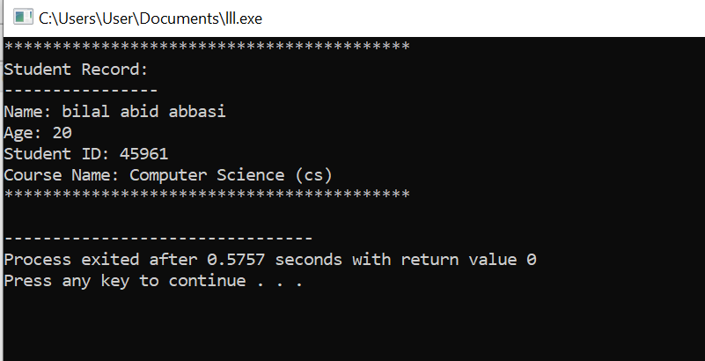

Question 2:

2. Transportation System – Overriding for Different Vehicles Scenario: A smart city traffic control system needs to manage how different vehicles start their engines. While every vehicle starts, the process differs (e.g., a car starts with a key, an electric scooter starts with a button, etc.). You are required to model this behavior using function overriding to handle the specific start logic for each vehicle type. Create a base class Vehicle with a virtual function startEngine() displaying a generic message like "Starting the vehicle...". Then, derive a class Car and override the function to display "Car engine started with a key." Similarly, create another class ElectricScooter that overrides the method with a message like "Electric Scooter started with a power button." In main(), use base class pointers or references to demonstrate runtime polymorphism by calling overridden methods based on object type. This task reflects a real-world use case in smart transportation systems, showing how different vehicles can have their own start mechanisms using function overriding. In the main() method, you will create objects of different vehicle types and use base class pointers to access overridden methods, demonstrating how polymorphism allows flexible and dynamic method calling at runtime.

Solution:
#include <iostream>
using namespace std;

class Vehicle {
public:

virtual void startEngine() { //function
cout << "Starting the vehicle..." << endl;
}
};

class Car : public Vehicle { // Derived class:
public:
void startEngine() override {
cout << "Car engine started with a key." << endl;
}
};

class ElectricScooter : public Vehicle { // Derived class
public:
void startEngine() override {
cout << "Electric Scooter started with a power button." << endl;
}
};

int main() {

Vehicle* v; // Base class pointer

Car car1;
ElectricScooter scooter1;

v = &car1; // Pointing to Car object
v->startEngine();

// Pointing to ElectricScooter object
v = &scooter1;
v->startEngine(); // Calls ElectricScooter's version

return 0;
}

Output:

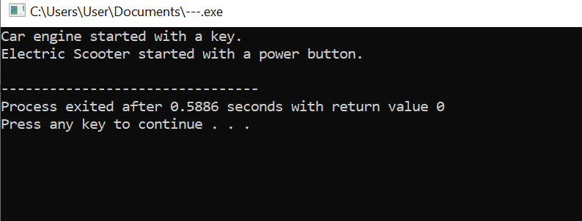

Question 3:

3. Employee Payroll System – Hierarchical Class Structure Scenario: A company wants to develop an employee payroll system where they handle full-time and part-time employees. Both employee types share common details like name and ID but differ in how their salary is calculated. The system should use a class hierarchy to represent this structure cleanly and efficiently. Define a base class Employee with common attributes such as name, employeeID, and a method displayInfo(). Create two derived classes: FullTimeEmployee with additional member monthlySalary, and PartTimeEmployee with members hourlyRate and hoursWorked. Each class should have a method to calculate and display salary. Use inheritance to avoid duplicating common fields and methods. In the main() method, create one object of each derived class and display their complete information and computed salary. This lab task is based on a real-time payroll system, where different employee types are handled using a class hierarchy. The main() function will create instances of FullTimeEmployee and PartTimeEmployee, assign data, and call appropriate methods. This task teaches students how to build scalable and maintainable systems using inheritance and object-oriented principles in C++.

Solution:

#include <iostream>
using namespace std;
class Employee {
protected:
string name;
int employeeID;

public:
void setEmployeeInfo(string n, int id) {
name = n;
employeeID = id;
}

void displayInfo() {
cout << "Name: " << name << endl;
cout << "Employee ID: " << employeeID << endl;
}
};

class FullTimeEmployee : public Employee {
private:
double monthlySalary;

public:
void setFullTimeData(double salary) {
monthlySalary = salary;
}

void displaySalary() {
cout << "Monthly Salary: " << monthlySalary << endl;
}
};

class PartTimeEmployee : public Employee {
private:
double hourlyRate;
int hoursWorked;

public:
void setPartTimeData(double rate, int hours) {
hourlyRate = rate;
hoursWorked = hours;
}

void displaySalary() {
double salary = hourlyRate * hoursWorked;
cout << "Salary (Hourly): " << salary << endl;
}
};

int main() {
// Full-time employee object
FullTimeEmployee emp1;
emp1.setEmployeeInfo("Ahmed Ali", 101);
emp1.setFullTimeData(50000);

cout << "Full-Time Employee Details:" << endl;
cout << "---------------------------" << endl;
emp1.displayInfo();
emp1.displaySalary();

cout << endl;

// Part-time employee object
PartTimeEmployee emp2;
emp2.setEmployeeInfo("Sara Khan", 202);
emp2.setPartTimeData(500, 40);

cout << "Part-Time Employee Details:" << endl;
cout << "---------------------------" << endl;
emp2.displayInfo();
emp2.displaySalary();

return 0;
}

Output:

